|  |  |  |
| --- | --- | --- |
| **شعار جامعة بنها الجديد**f |  | **logo.jpg** |

**El Fankosh**

A summer training project submitted in partial fulfillment of the requirements for the degree of Bachelor of Computers and Informatics.

**2st Year Students Summer Training**

*Project Team*

1. Abdelrahman Mohammed ahmed
2. Abdelrahman Abas Mohamed
3. Mohammed Abdelrhem Abdelrhem
4. Hagar Reda Mohammed
5. Eman Gamal Abdelnaser
6. Aya Ramadan Saleh

Benha, August 2022

We hereby certify that this project, submitted by the project teamwork, conforms to acceptable standards and is fully adequate in scope and quality to fulfill the seminar requirements for the degree of Bachelor of Computers and Informatics.

**Discussion Committee:**

____________________________________ ________________

Date

____________________________________ ________________

Date

____________________________________ ________________

Date

**Abstract**

In today’s fast-changing business environment, it’s extremely important to be able to respond to client needs in the most effective and timely manner. If your customers wish to see your business online and have instant access to your products or services.

Online Shopping is a lifestyle e-commerce web application, which retails various fashion and lifestyle products (Currently Men’s Wear). This project allows viewing various products available enables registered users to purchase desired products instantly using PayPal payment processor (Instant Pay) and also can place order by using Cash on Delivery (Pay Later) option. This project provides an easy access to Administrators and Managers to view orders placed using Pay Later and Instant Pay options.

In order to develop an e-commerce website, a number of Technologies must be studied and understood. These include multi-tiered architecture, server and client side scripting techniques, implementation technologies such as Larvel, programming language (such as PHP) and relational databases. This is a project with the objective to develop a basic website where a consumer is provided with a shopping cart application and also to know about the technologies used to develop such an application.

This document will discuss each of the underlying technologies to create and implement an e- commerce website.

## TABLE OF CONTENTS

ABSTRACT 3

ACKNOWLDEGEMENT 4

LIST OF FIGURES 6

1.0 INTRDUCTION 7

* 1. OVERALL DESCSRIPTION 7
  2. DESCRIPTION 7
  3. USING THE CODE 8
  4. MASTER PAGE DETAILS… 8
  5. WEB PAGES DETAILS 8
  6. PROJECT DETAILS 8
  7. SYSTEM REQUREMENT 9
  8. USE-CASE DIAGRAM 9
  9. ONLINE SHOPPING APPLICATION 9

### HOME PAGE

* 1. **CLOTHING PAGE ( PRDUCTS)**

### ORDER US PAGE

* 1. **CONTACT US PAGE**

### ABOUT US PAGE

* 1. **TRACK FOR ADMIN PAGE**

### REGISTER PAGE

* 1. **LOGIN**

### ADMIN PAGE

* 1. **ORDER VIEW FOR USER**

### PAYPAL FOR PAYMENT

* 1. **SUCCESS PAGE**

### FAILED PAGE

* 1. **DATA MANAGEMENT 16**

### DATA DESCRIPTION

* 1. **DATA OBJECTS**

### DATA TABLE DIAGRAM

* 1. **RELATIONSHIPS**

**6.0 CONCLUSION 19**

**7.0 REFERENCE 21**

**Introduction**

E-commerce is fast gaining ground as an accepted and used business paradigm. More and more business houses are implementing web sites providing functionality for performing commercial transactions over the web. It is reasonable to say that the process of shopping on the web is becoming commonplace.

The objective of this project is to develop a general purpose e-commerce store where product like clothes can be bought from the comfort of home through the Internet. However, for implementation purposes, this paper will deal with an online shopping for clothes.

An online store is a virtual store on the Internet where customers can browse the catalog and select products of interest. The selected items may be collected in a shopping cart. At checkout time, the items in the shopping cart will be presented as an order. At that time, more information will be needed to complete the transaction. Usually, the customer will be asked to fill or select a billing address, a shipping address, a shipping option, and payment information such as credit card number. An e-mail notification is sent to the customer as soon as the order is placed.

## OVERALL DESCRIPTION:

### Description:

* + - Any member can register and view available products.
    - Only registered member can purchase multiple products regardless of quantity.
    - ContactUs page is available to contact Admin for queries.
    - There are three roles available: Visitor, User and Admin.
      * Visitor can view available products.
      * User can view and purchase products.
      * An Admin has some extra privilege including all privilege of visitor and user.
        + Admin & User can add products, edit product information and add/remove product.
        + Admin can add user, edit user information and can remove user.
        + Admin can ship order to user based on order placed by sending confirmation mail.

### Using the code:

1. Attach the database in your "SQL Express".
2. Run the application on Microsoft Visual Studio as web site.
3. Locate the database.

### MasterPage details:

* + - OnlineShopping Master Page (Similar MasterPage for Visitor, User and Admin)

### Web Pages details:

* + - Home Page
    - AboutUs Page
    - Clothing Page
    - OrderUs Page
    - ContactUs Page
    - Admin Page
    - Login Page
    - Register Page
    - Track
  1. **Project Detail:**

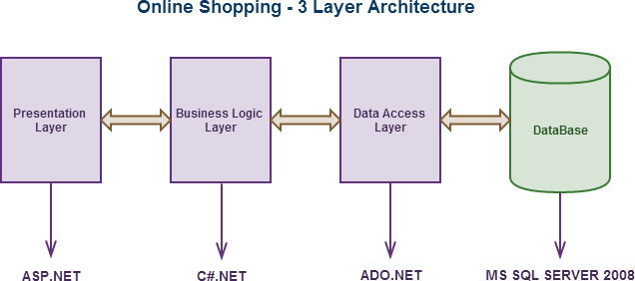

* 1. **SYSTEM REQUREMENTS:**
  2. **USE-CASE DIAGRAM:**

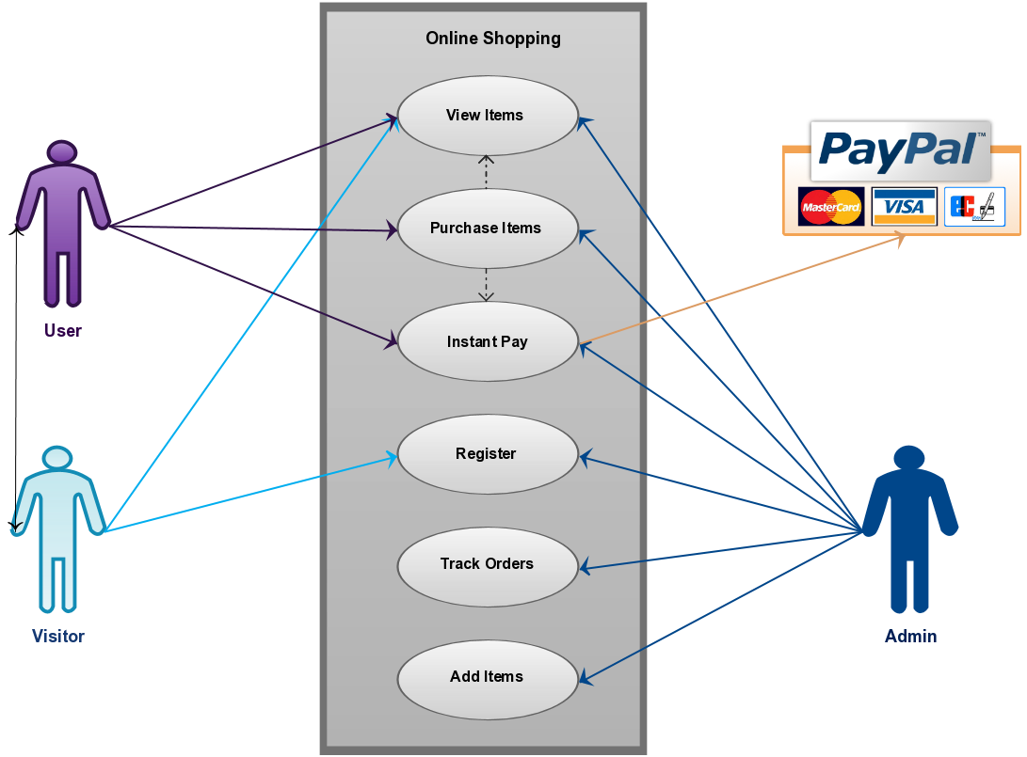



## ONLINE SHOPPING APPLICATION:

Anyone can view Online Shopping portal and available products, but every user must login by his/her Username and password in order to purchase or order products. Unregistered members can register by navigating to registration page. Only Admin will have access to modify roles, by default developer can only be an ‘Admin’. Once user register site, his default role will be ‘User’.

* 1. **HOMEPAGE:** The Home Screen will consist of screen were one can browse through the products which we have on our website

**Figure1: Home Page**

**4.2. CLOTHING PAGE (PRODUCTS):** This page consists of product details. This page appears same for both visitors and users.

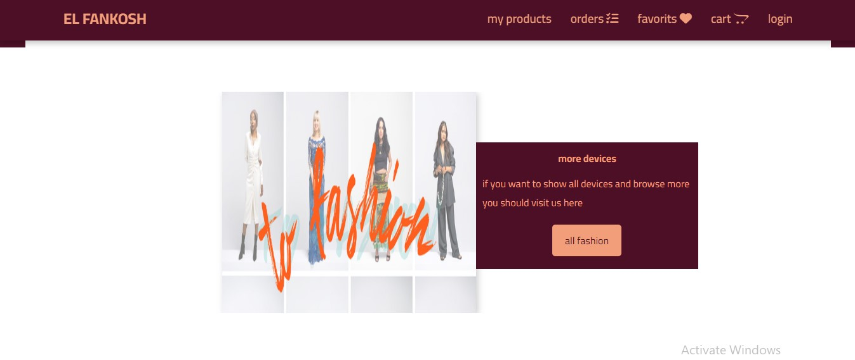

Figure 2: Clothing Page

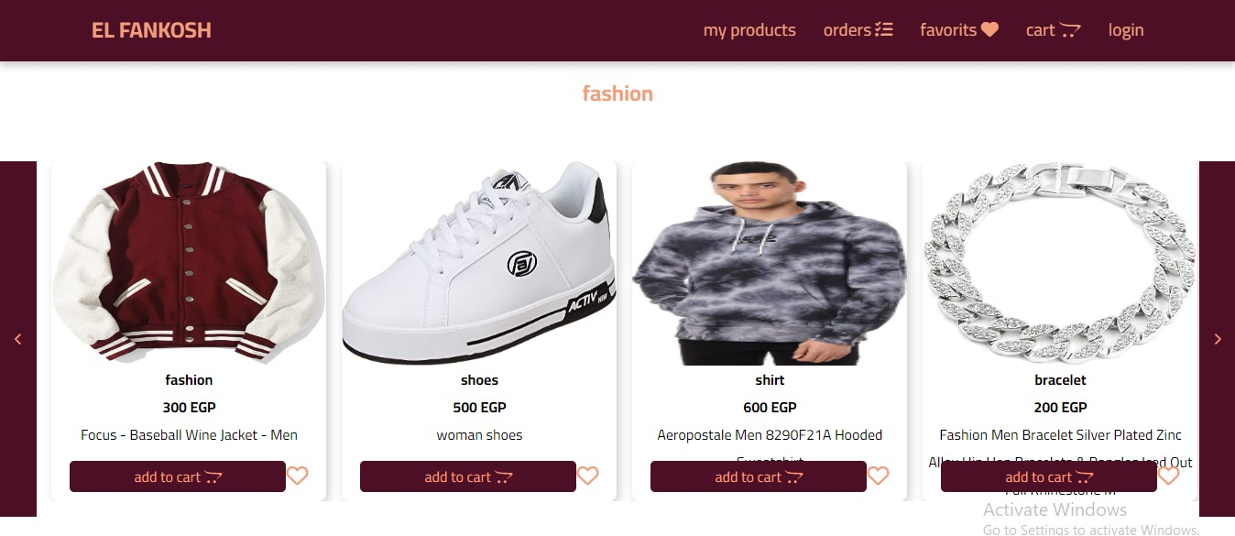

* 1. **Kids Products:** user can choose kids product .

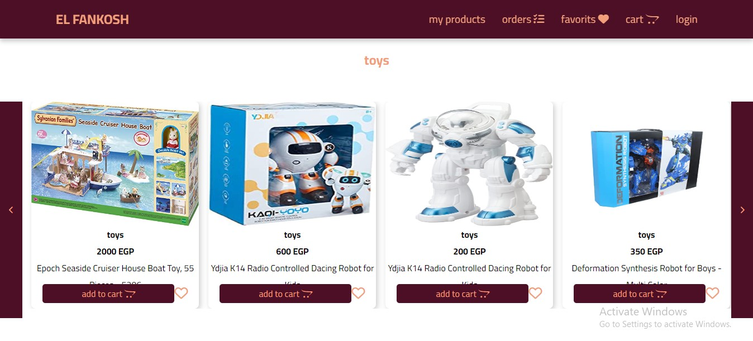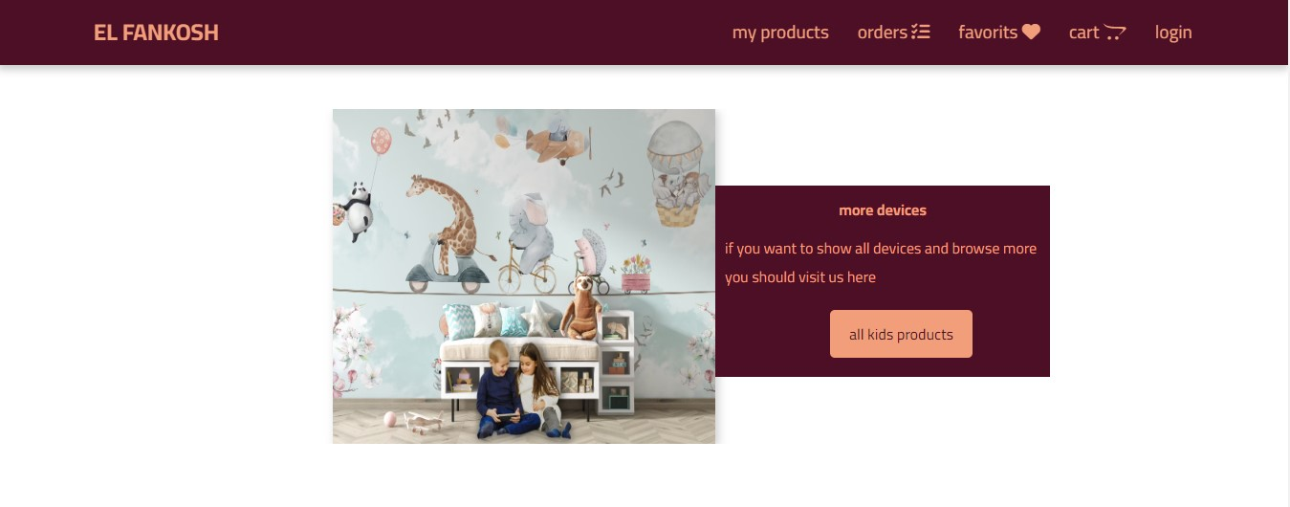



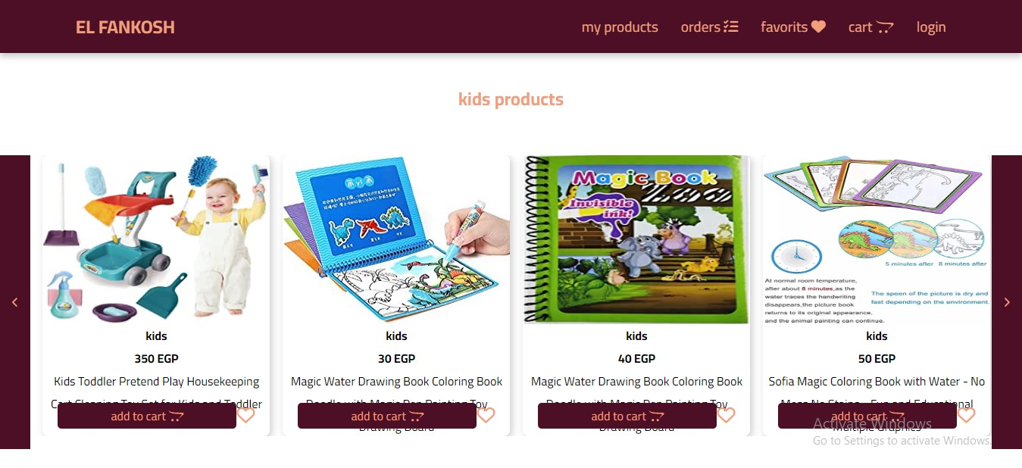

* 1. **Smart Devicses Page:** Visitors and Registered users can chose smart devices from this page

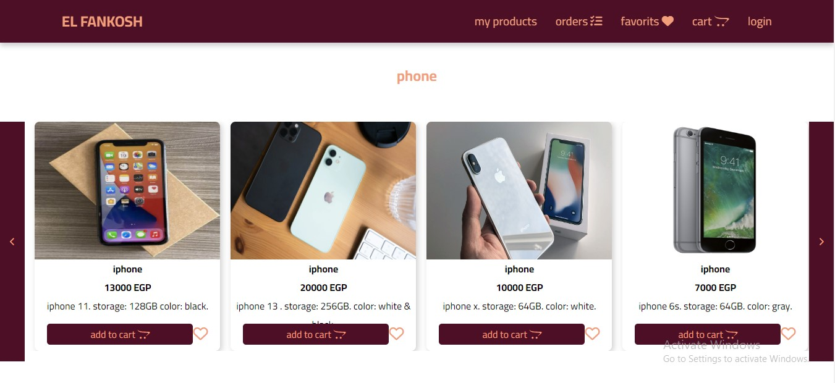

* + 1. **Lab tops Page**

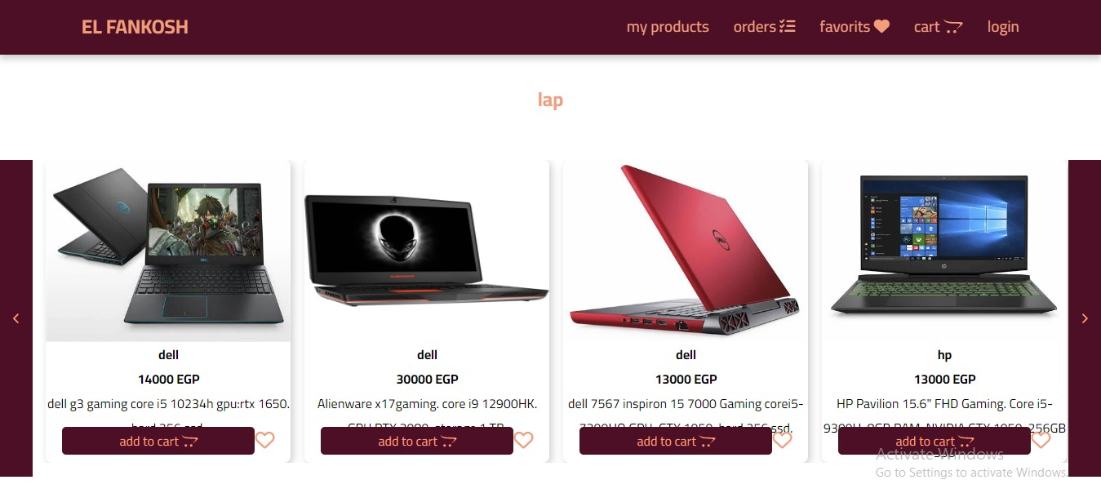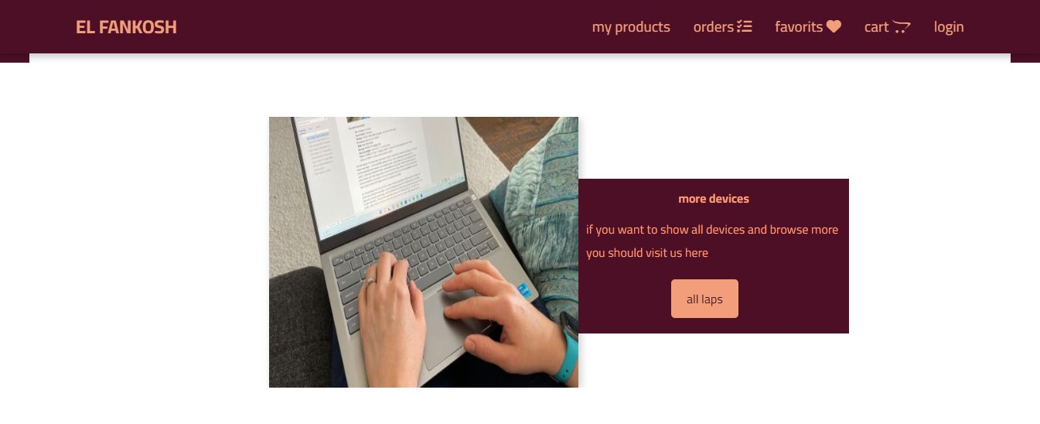

* 1. **Video Game Section :** This page Show Video Game Product

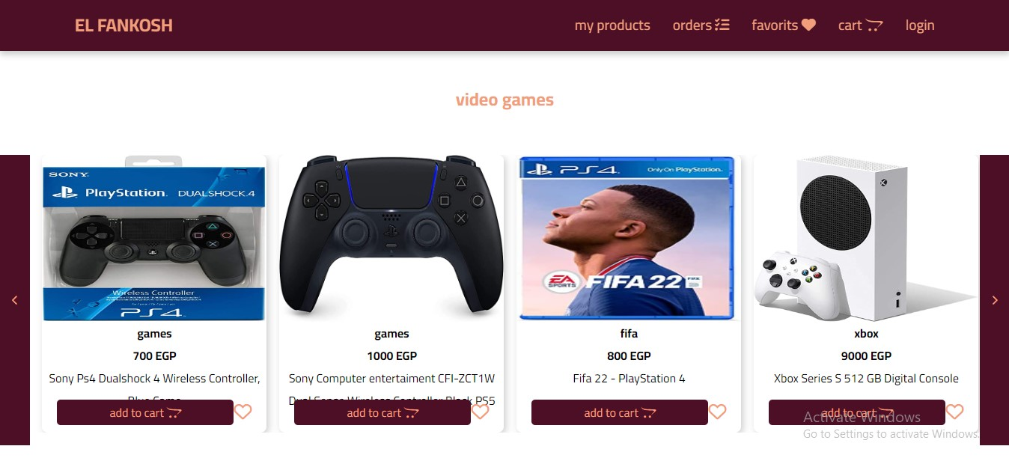

* 1. **Furniture Page :** This page Show Furniture Product.

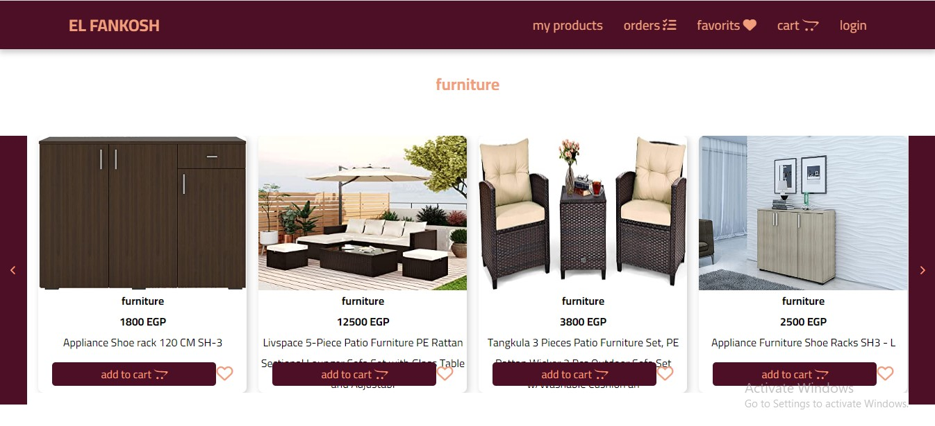

* 1. **Accessory Page:** this Page display Accessory products

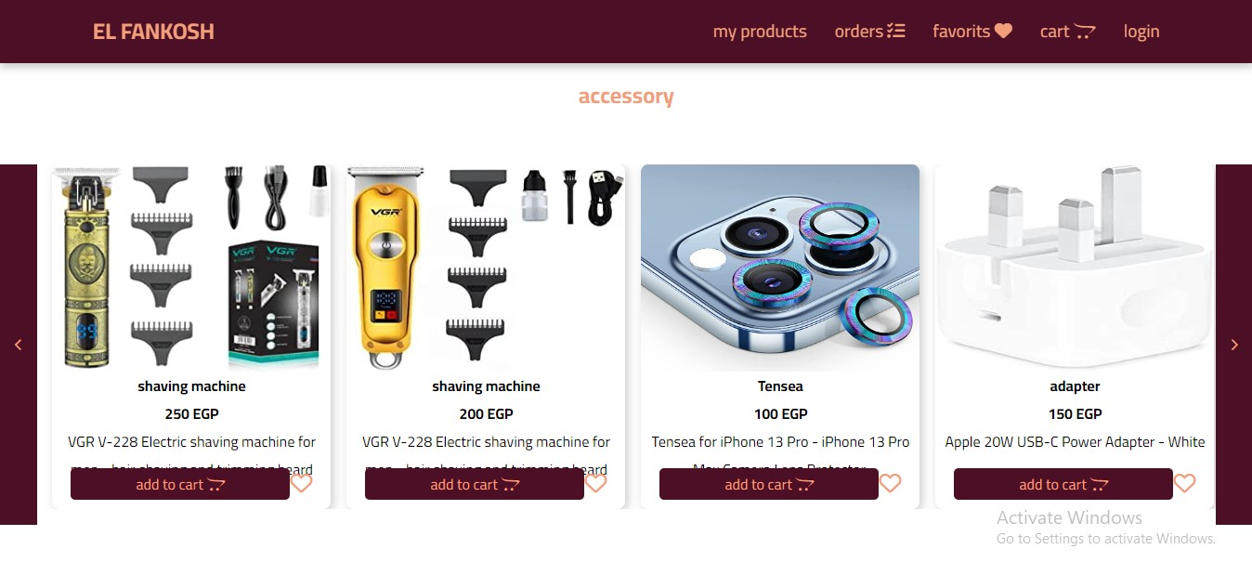

4.8 **More Details and similar Products Page** :This page display More Details About Proudct .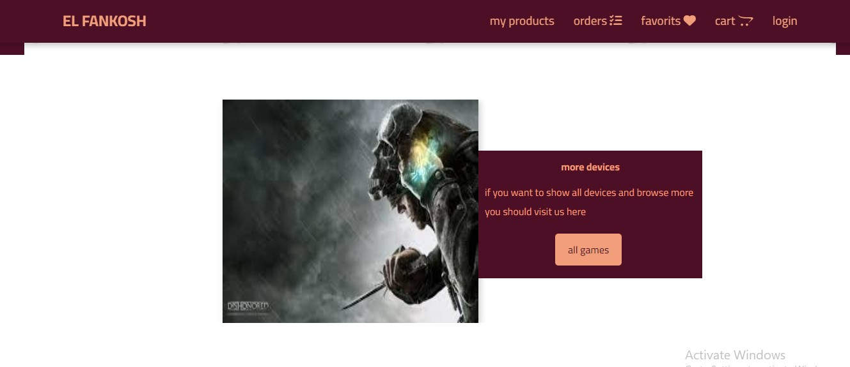

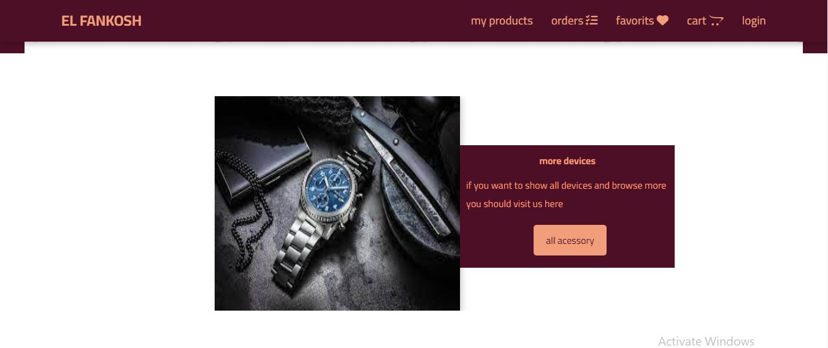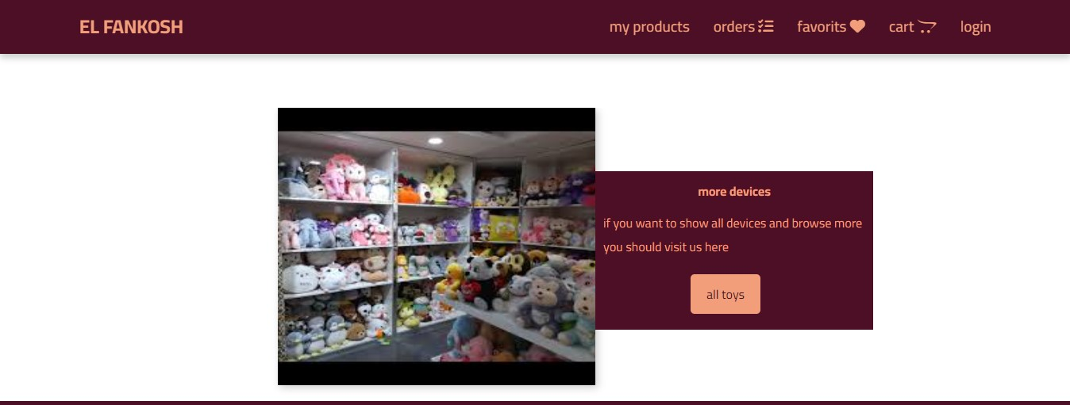

* 1. **LOGIN PAGE:** Login page for both users and administrators.

* 1. **ORDER VIEW FOR USER:** Once users order item they are able to see ordered products and grand total.

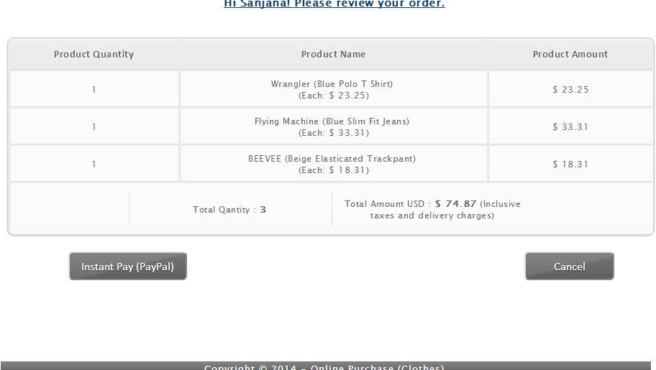

## Data Management

### Data Description

This database consists of

* + - Users: User and Admin information is added to database with Unique ID based on their roles.
    - Shopping: Complete products information is stored in this table.
    - Orders: Customer ordered products, status and delivery information is stored in this table.
  1. **Data Objects**
     + User: ID, UserName, Password, Email, Role
     + Shopping: ID, Product, Product ID, Cost, Category, Image, Description
     + Orders: ID, Client, Product, Quantity, Price, Date, OrderShipped
  2. **Database Table Diagram**

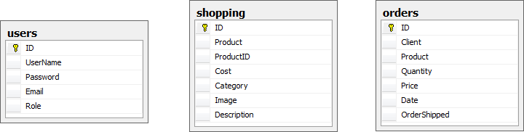

* 1. **Relationships:**

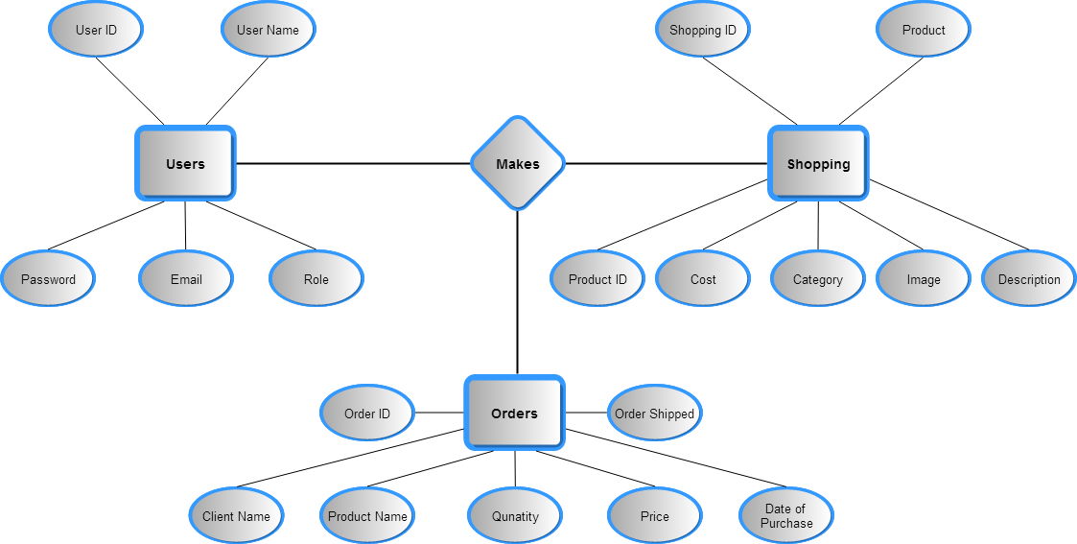

* **ERD**

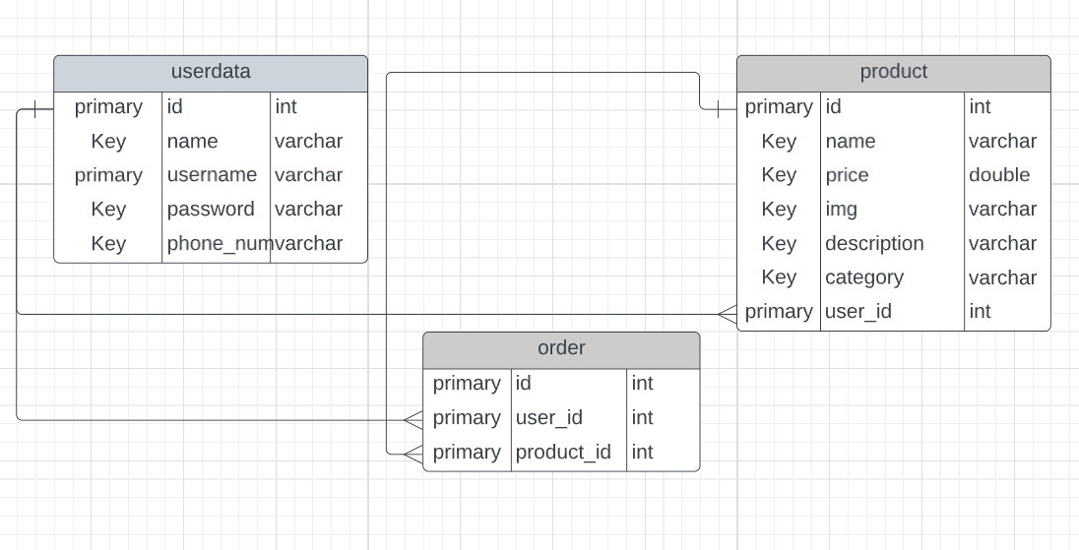

**Implementions**

* For Add New Product

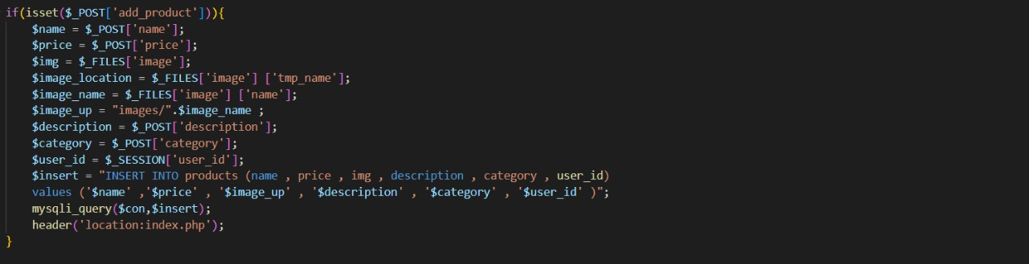

* To Add product in favourite

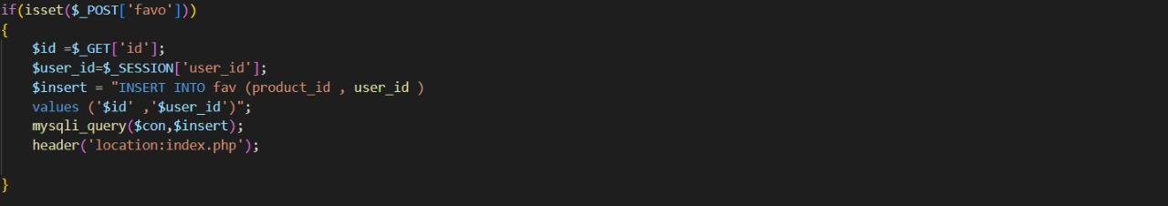

* Product Modification

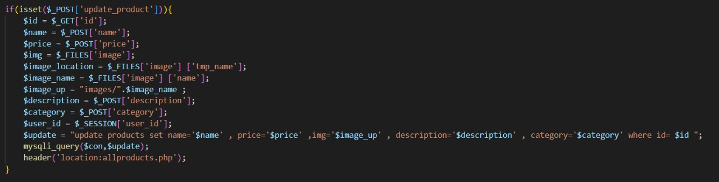

* Make New Account

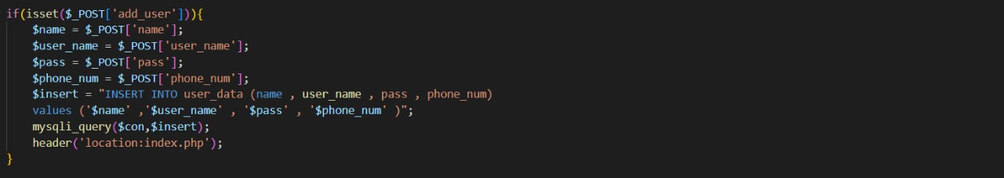

* Account verfcation

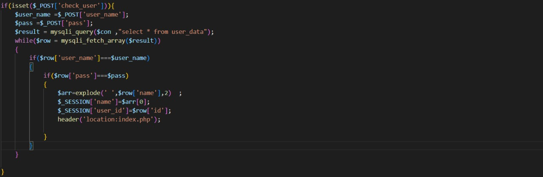

* Delete Product

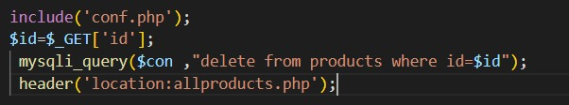

* Data Base connection



**Future Work**

* 1. **PAYPAL FOR PAYMENT:** Once users orders products they are redirected to payment page.

L 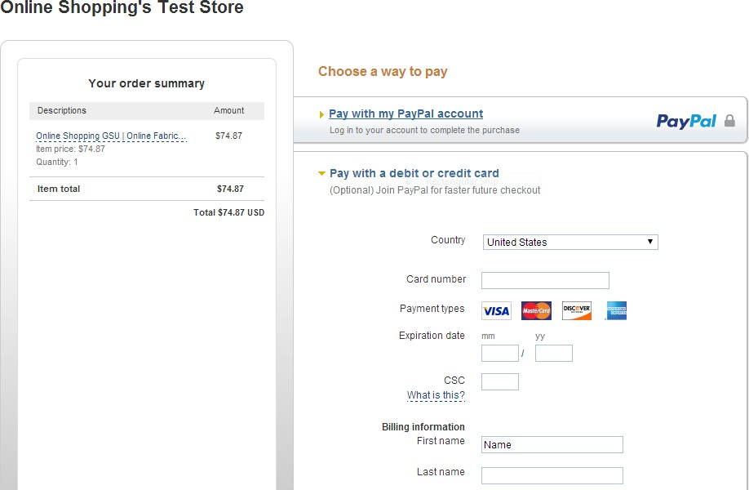

Figure 11: PayPal Page

### Figure 4.12: Success URL

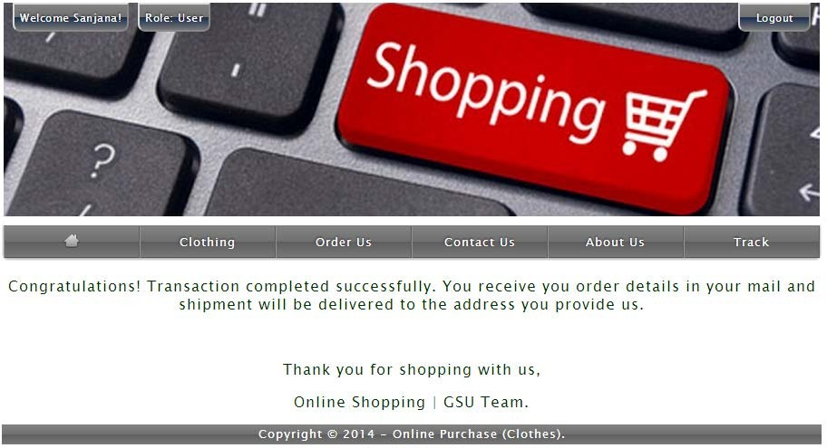

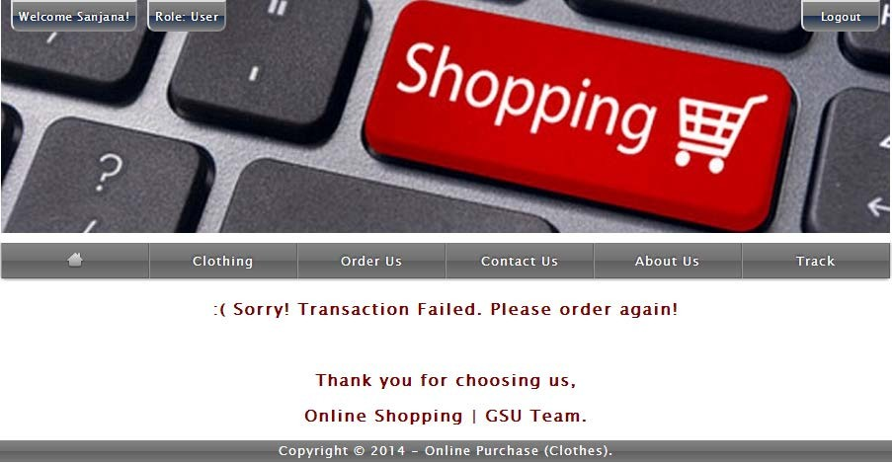

## 6.0 Conclusion:

The Internet has become a major resource in modern business, thus electronic shopping has gained significance not only from the entrepreneur’s but also from the customer’s point of view. For the entrepreneur, electronic shopping generates new business opportunities and for the customer, it makes comparative shopping possible.

As per a survey, most consumers of online stores are impulsive and usually make a decision to stay on a site within the first few seconds. “Website design is like a shop interior. If the shop looks poor or like hundreds of other shops the customer is most likely to skip to the other site. Hence we have designed the project to provide the user with easy navigation, retrieval of data and necessary feedback as much as possible. In this project, the user is provided with an e- commerce web site that can be used to buy books online. To implement this as a web application we used ASP.NET as the Technology. ASP.NET has several advantages such as enhanced performance, scalability, built-in security and simplicity.

To build any web application using Larvel we need a programming language such as PHP, , Js and so on. PHP was the language used to build this application. For the client browser to connect to the Larvel engine we used Microsoft’s Internet Information Services (IIS) as the Web Server. ASP.NET uses ADO.NET to interact with the database as it provides in-memory caching that eliminates the need to contact the database server frequently and it can easily deploy and maintain an ASP.NET application. SQL was used as back-end database since it is one of the most popular databases, and it provides fast data access, easy installation and simplicity.

A good shopping cart design must be accompanied with user-friendly shopping cart application logic. It should be convenient for the customer to view the contents of their cart and to be able to remove or add items to their cart. The shopping cart application described in this project provides a number of features that are designed to make the customer more comfortable.

This project helps in understanding the creation of an interactive web page and the technologies used to implement it. The design of the project which includes Data Model and Process Model illustrates how the database is built with different tables, how the data is accessed and processed from the tables. The building of the project has given me a precise knowledge about how ASP.NET is used to develop a website, how it connects to the database to access the data and how the data and web pages are modified to provide the user with a shopping cart application.

## 7.0References:

* + 1. Anne Boehm, Joel Murach, Murach’s ASP.NET 4 Web Programming with C# 2010, 4th Edition, Murach, 2010.
    2. Bryan Syverson, Joel Murach, Murach’s SQL Server 2012 for developers, Murach, 2012.
    3. <http://www.w3schools.com/>
    4. <http://msdn.microsoft.com/>
    5. <http://agilemodeling.com/>
    6. <http://csharp-video-tutorials.blogspot.co.uk/p/free-dot-net-video-tutorials-for.html>